**EN2550 - Assignment 2 on Fitting and Alignment**

**Name**: C. J. Kurukulasuriya

**Index Number**: 190337X

**GitHub**: <https://github.com/chira99/image-processing-opencv-python.git>

**Question 01**

1. RANSAC algorithm for circle estimation is implemented as follows.
2. def RANSAC_circ(X):
4. e = 0.5     # outlier ratio
5. s = 3       # Number of points needed to create the estimated model
6. p = 0.99    # probability that at least 1 sample is free from outliers
7. t = 1.96 * 10/16   # treshold
8. d = 50      # expected inlier count
10. iters = int(np.ceil(np.log(1-p)/np.log(1-(1-e)**s)))
12. best_inlier_count = 0
13. best_samples = None
14. best_fit_inliers = None
16. for _ in range(iters):
17. # Choose 3 distinct points from dataset
18. [p1, p2, p3] = np.random.choice(len(X), size=3, replace=False)
19. [p1, p2, p3] = X[p1, :], X[p2, :], X[p3, :]
21. # Get circle through the 3 points
22. f, g, r = getCircle(p1, p2, p3)
24. if r == None:
25. continue
27. inlier_count, inliers = getInlierCount(f, g, r, X, t)
29. if inlier_count > best_inlier_count:
30. best_inlier_count = inlier_count
31. best_fit_inliers = inliers
32. best_samples = [p1, p2, p3]
33. best_fit_circle = [f, g, r]
35. if best_inlier_count < d:
36. # Repeat RANSAC if no model found
37. RANSAC_circ(X)
39. ransac_circle = bestFitCircle(best_fit_inliers) # returns f,g,r
41. return ransac_circle, best_fit_circle, best_samples, best_fit_inliers

Parameters of the algorithm:

* The minimum number of points needed to estimate the circle, **s = 3**
* A threshold of **t = 1.96*(r/16)** gives the required 95% probability of capturing all inliers since the dataset is corrupted by mean-zero variance-one gaussian noise. (r = 10)
* Consensus size, **d = 50**, since 50 points are inliers out of the given 100 dataset points.

1. The resulting circle fitting using RANSAC algorithm is as follows.

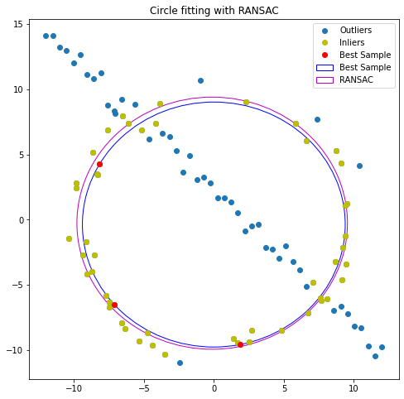

**Question 02**

1. Classical painting projected onto the wall of a display room.



1. Movie poster on billboard display.

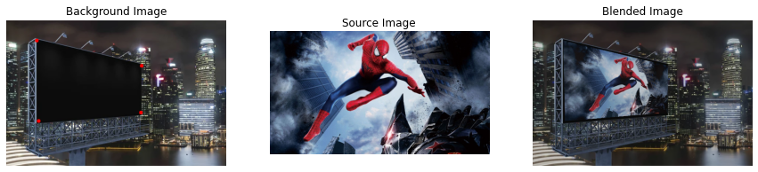

1. Sri Lankan flag projected/painted onto Sigiriya.

